Year 4: Leopards  Term 2: Autumn | 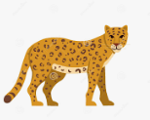

RESPECT | INDEPENDENCE | CONFIDENCE | CREATIVITY

Dear Parents and Carers,
Welcome back! We hope you had a lovely half term and enjoyed some Halloween fun.
This term will be a busy one as we head towards Christmas. Each Friday, your child will bring home 10 spelling words to practise for the following week’s test. Please support them by reviewing these words together and using Spelling Shed.
Reading with your child each night helps build fluency and confidence, and regular TT Rockstars practice will strengthen their times tables and maths skills.
The children are loving their OPAL playtime! As the weather gets colder, please send in named wellies and a waterproof suit.
Thank you for your continued support.
Miss Elvy
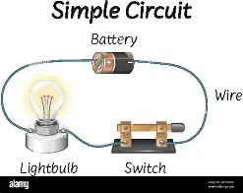
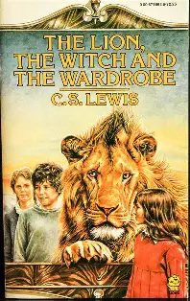
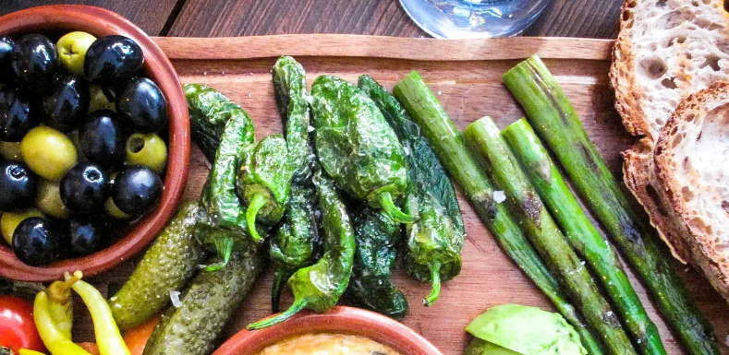
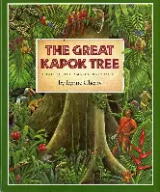
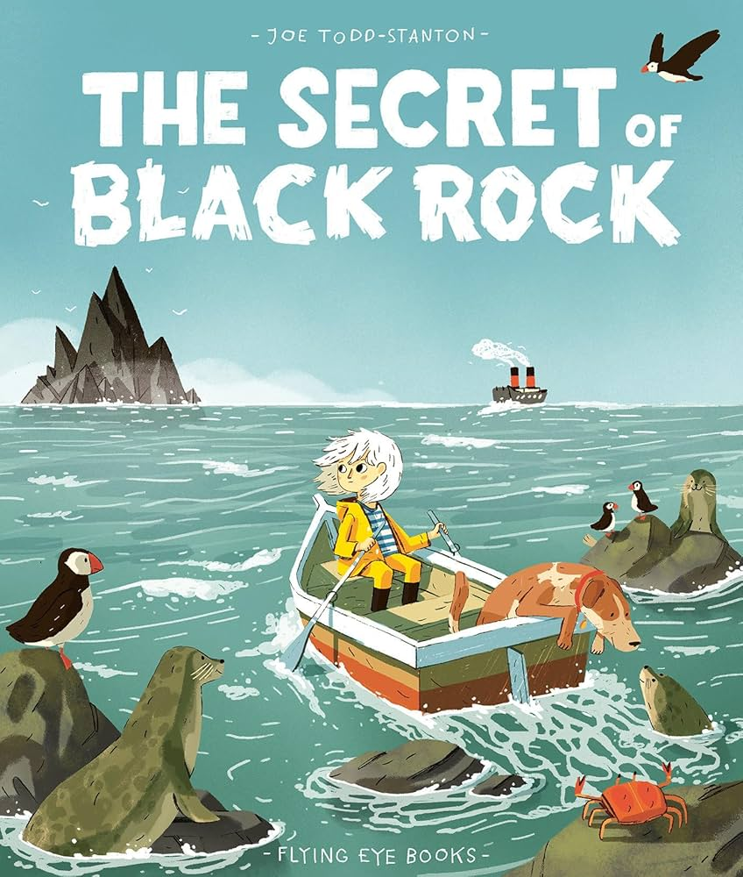
English: Writing | English: Reading | Maths
This term we will be writing spooky setting descriptions, story adaptations and a persuasive letter.  We will begin by exploring the book The Lion, the Witch and the Wardrobe where we will use Talk for Writing to build and use suspense to create a spooky tale of our own. We will then be using The Secret of Black Rock to create a story adaptation. We will spend some time focusing on pronouns, using the correct tense, similes, direct speech, fronted adverbials and varying our sentences to create suspense. For the last week, we will use The Great Kapok Tree, to write a persuasive letter. We will spend some time focusing on features of persuasive letters, such as persuasive language, rhetorical questions and emotive language. Within each genre of writing, we will analyse examples and pick out the key features. We will generate and gather ideas, plan, draft and edit our writing making use of modelled and shared writing. | Our focus texts this term are:  The Lion, the Witch and the Wardrobe by CS Lewis and The Secret of Black Rock by Joe Todd Stanton and The Great Kapok Tree by Lynne Cherry.  We will continue to develop our learning behaviours when reading this term to ensure that we can support and actively listen; Discuss and explain our ideas and Take responsibility for our own/group’s learning.  We will then continue to use our Destination Reader scheme to revisit core skills of questioning, predicting, making connections, clarifying, inferring, summarising and evaluating. | Our Maths focus this term is to move onto Area and Multiplication and Division.  We will be looking at finding the area of different shapes by counting squares, as well as comparing areas of two shapes.  We will continue to practise the times tables the children have already been taught (2, 3, 4, 5, 8 and 10). We will then focus on learning to multiply and divide in 3s, 6s, 9s, 7s, 11s and 12s. The children need to ensure they are continuing to practise their times tables using ‘TTRockstars’ or just writing them down as this will help the children mentally remember each answer.
Science | Geography/History | Religious Education (RE)
Our topic for science this term is Electricity and Circuits. In the upcoming lessons, we will expand our knowledge by exploring how to classify everyday appliances, build and test simple circuits, and investigate how open and closed switches control the flow of electricity. We will also test different materials to discover which ones act as electrical conductors and insulators, examine how adding extra bulbs to a series circuit affects their brightness, and learn essential safety precautions for working with electricity. | In Geography, we will begin our new topic Where does our food come from? We will identify different biomes around the world and what different foods they produce. We will also compare differences in climate and why this may mean certain foods are grown in certain places. We will explore which foods have the most negative impact on the environment and what we can do to reduce this. We complete the unit by investigating fair trade and the journey of a cocoa bean. | In this unit, we will find out about the events of Pentecost found in the Bible, considering which events would be needed to retell the story for someone else. We will begin to consider what the events found in Acts 2 might have meant for the first Christians and what they mean for Christians today. We will then make links between the description of the day of Pentecost in Acts 2, the Holy Spirit and the Kingdom of God. At the end of the unit, we will learn how Christians today show their beliefs about the Holy Spirit in worship and the way that they live their lives
French | Music | Art/ Design and Technology
This term our topic is Clothes – Getting Dressed in French. We will begin by learning vocabulary related to clothing and then use our prior knowledge to form sentences describing the clothing. | During this term, we will put our musical and physical skills together by performing the hand jive actions in sequence and in time with the music while singing in tune. We will also get to play the walking bass notes in the correct sequence, working independently on ours part while staying aware of how the other performers around you sound and move. | In the upcoming art lessons, we will develop our painting and observational skills by mastering the use of tone, tint, and shade. We will learn how to mix colours with black and white to create smooth tonal variations, identify highlights, midtones, and shadows on objects, and use these techniques to make 2D shapes appear three-dimensional. Additionally, we will explore composition by deliberately arranging objects for a still life, using art vocabulary to describe elements like light and balance, and ultimately apply these skills to create a complete still life painting with realistic 3D form.
Physical Education (PE) | Computing | Personal, Social and Health Education (PSHE)
This term we will have one session a week with Elite sports where we will focus on ball skills. | In this unit, we will learn how to design and build our own interactive games using Scratch. We will explore fundamental programming concepts by learning how to use and explain variables, track data, and understand how conditions change gameplay. | Our PSHE learning this term is Celebrating Differences. We will begin the unit by looking at all the ways people are different and accepting people for this, with a focus on making judgements of people’s appearances. We will move on to look at how other influences can affect our judgement and how we can manage this. We will use a variety of scenarios to identify and explore what bullying behaviour looks like, and how we can help people in this situation. We will complete the unit by celebrating our individual differences.
Reminders:
Our main PE day is Tuesday.

Homework
-Spelling word list and Spelling Shed activities are set on a Friday and will be based on spelling patterns to be taught the following week.
-Children are expected to practice their times tables regularly at home which can be done using Times Tables Rock Stars.
- Children should be reading every day at home (this should be logged in their reading record book).

Pupils to do not need to bring in anything of their own to school; this prevents it getting lost, broken or causing upsets with friendships. Pupils should not wear jewellery other than a simple set of earrings, and long hair should be tied back. Thank you for your support with this.

Capel-le-Ferne Primary School, Capel Street, Capel-Le-Ferne, Folkestone, Kent, CT18 7HB
Website: www.capelleferneprimary.co.uk Email: office@capel-le-ferne.kent.sch.uk

