  Year R: Honeybees  Term 1: Me and My Community | 
Key Vocabulary linked to our topic:
School | Friends | Independent | Feelings | Happy | Afraid
Teacher | Family | Rules | Kind | Sad | Calm
Community | Help | Routine | Caring | Angry | Love

RESPECT | INDEPENDENCE | CONFIDENCE | CREATIVITY

Dear Parents and Carers,
Hello and the warmest of welcomes to you! Can you believe it is September already and the children are starting school! I hope you took many first day photographs! We have a lovely ‘Me and my community’ topic to kick off our school year. This is a fantastic topic to help your child settle into school, get to know the staff, make new friends, learn our routine and be independent around our classroom. We will be working hard to get to know your child so they settle quickly and calmly and are happy coming into school. We know you know your child best and I look forward to working with you to give your child the best start to their school career! Any questions or queries please do not hesitate to ask!
Baseline Assessment
When your child starts school we are required to carry out a statutory assessment within the first 6 weeks of Reception. This focuses on language, communication, literacy and mathematics and is used to measure progress at the end of Year 6. If you would more information about this assessment please go to the following website.
https://www.gov.uk/government/publications/reception-baseline-assessment-information-for-parents
Stories we will be reading:
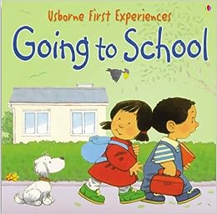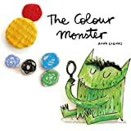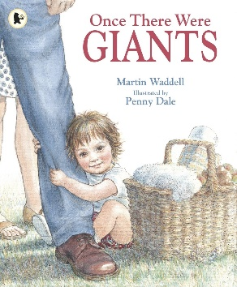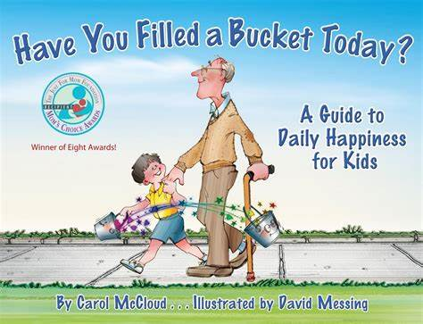
English: Writing and Reading | English: Phonics | Maths
This half term we will be continuing to focus on  - Name recognition and writing  - Prewriting mark making  High frequency word recognition  We will be sending home a tricky word sheet. Please support your child to read and remember these, as they will help with their reading fluency. This can be focusing on 1-2 new words a week. | Phase 1 Phonics- Pre-reading skills  Week 1-3 General sound discrimination - Environmental and instrumental sounds and body percussion, alliteration (words that have the same sounds) and voice sounds.  Week 4-8- Repeating above and adding in rhythm (counting syllables), oral blending (saying the sounds and asking if the children can work out the words eg c-a-t = cat) and segmenting (saying the word and asking children to break it apart eg cat = c-a-t).  Any question or for more information please speak to Miss Clarke. | Week 1- 3 Baseline focus  Week 4- Amazing shapes  Week 5-8 Mastering Number
How can you help at home?  - Each child has been given a name card. You can use this to support your child when learning to write their name at home.  - Ask your child questions about stories they have listened to and checking their understanding of words in the story. |  | How can you help at home?  - Practice counting to 20  - If you have a dice at home – Please look at the dice and challenge your child to recognise the value of the dots without counting them- this is called subitising.  - Look for things that are the same using language such as same and different
Understanding of the world | Personal, Social and Emotional | Expressive Arts and Design
This half term we will be continuing to focus on  - Learning about the school community  - Making new friends  - Talking about family  - Times for celebrations eg- harvest festival and birthdays | This half term our Jigsaw Topic is called Being Me in My World  Week 2- I understand how it feels to belong and that we are similar and different  Week 3- I can start to recognise and manage my feelings  Week 4- I enjoy working with others to make school a good place to be  Week 5- I understand why it is good to be kind and use gentle hands  Week 6- I am starting to understand children’s rights and this means we should all be allowed to learn and play  Week 7- I am learning what being responsible means | This half term we will be continuing to focus on  - Exploring paint  - Exploring tools  - Mark making  - Music  - Singing  - Adding detail to our art  - Colour mixing
Communication and Language | Physical Development
This half term we will focus on  - Stories  - Why listening is important  - Singing  - Having conversations  - Talking about our thoughts, feelings and ideas  - Using longer sentences  - Developing our vocabulary  - Being polite  - Asking questions  - Describing stories and experiences | This half term we will focus on  - Using cutlery at lunch  - Ball skills  - Holding a pencil correctly  - Lining up with our friends  - Refining fundamental movements such as rolling, crawling, walking, jumping, running, skipping, climbing and hopping  - Drawing  - Balancing  - Co-ordination  - Fine motor skills – getting those little fingers moving
Reminders:
Outdoor learning is on Wednesday afternoons.
PE day is Friday. Children are to come to school in their PE kit.
Homework is due in every Wednesday.

Dates for your diary:

Autumn 1 Topic- Me and My Community
Capel Park trip- Thursday 21st October (We will need 3 helpers for this trip please let Miss Clarke know if you can help ).
Harvest Festival – Thursday 8th October- 9.30am. School hall
Tuesday 20th and Wednesday 21st October- Parents Evening (more details to follow)
Friday 23rd October- Pyjamarama (more details to follow)
Party afternoons this half term will be on Friday 25th September and Friday 23rd October. Children can bring in 1 toy from home and a special snack.

Autumn 2 Topic- Amazing Autumn/ Winter Wonderland
Party afternoon this half term will be on Friday 27th November and 18th December. Children can bring in 1 toy from home and a special snack.

Spring 1 Topic- Stories
Party afternoon this half term will be on Friday 29th January. Children can bring in 1 toy from home and a special snack.

Spring 2- Topic -Ready Steady Grow
Biking afternoon- Wednesday 10th March- Children can bring in their bike or scooter for a biking afternoon. Please ensure your child has a helmet for this activity.
Sleep day – Thursday 18th March - We will be thinking about the importance of sleep. The children can come into school in their pyjamas and parents are invited to join us at 2.50pm for a Bedtime Story Session. Please bring a torch and a story you would like to read with your child.
Kent Life- Farm visit including From grain to bread roll workshop- Thursday 25th March.
Party afternoon this half term will be on Friday 26th February and Thursday 25th March. Children can bring in 1 toy from home and a special snack.

Summer 1 Topic- Big Wide World
Wingham Wildlife Trip – Thinking about wild animals and their habitats- TBA
Party afternoon this half term will be on Friday 30th April and Thursday 28th May. Children can bring in 1 toy from home and a special snack.

Summer 2 Topic- On the beach
Class Assembly -TBA
Beach trip- Looking at rock pools and exploring the beach- Families and siblings welcome. Monday 12th July.
Party afternoon this half term will be on Friday 25th June and 16th July. Children can bring in 1 toy from home and a special snack.

Capel-le-Ferne Primary School, Capel Street, Capel-Le-Ferne, Folkestone, Kent, CT18 7HB
Website: www.capelleferneprimary.co.uk Email: office@capel-le-ferne.kent.sch.uk

